**4. INTERFACE**

**4.1 Layout Diagram**

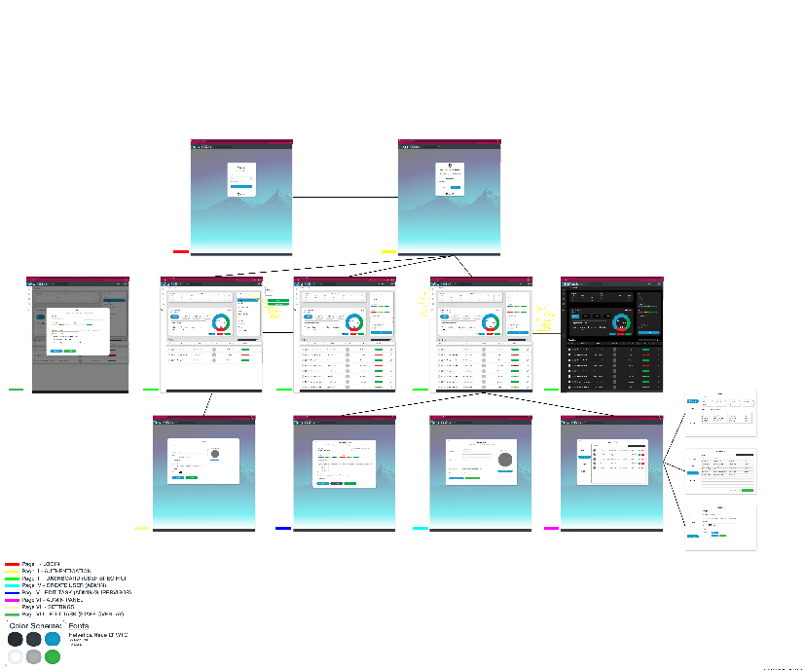

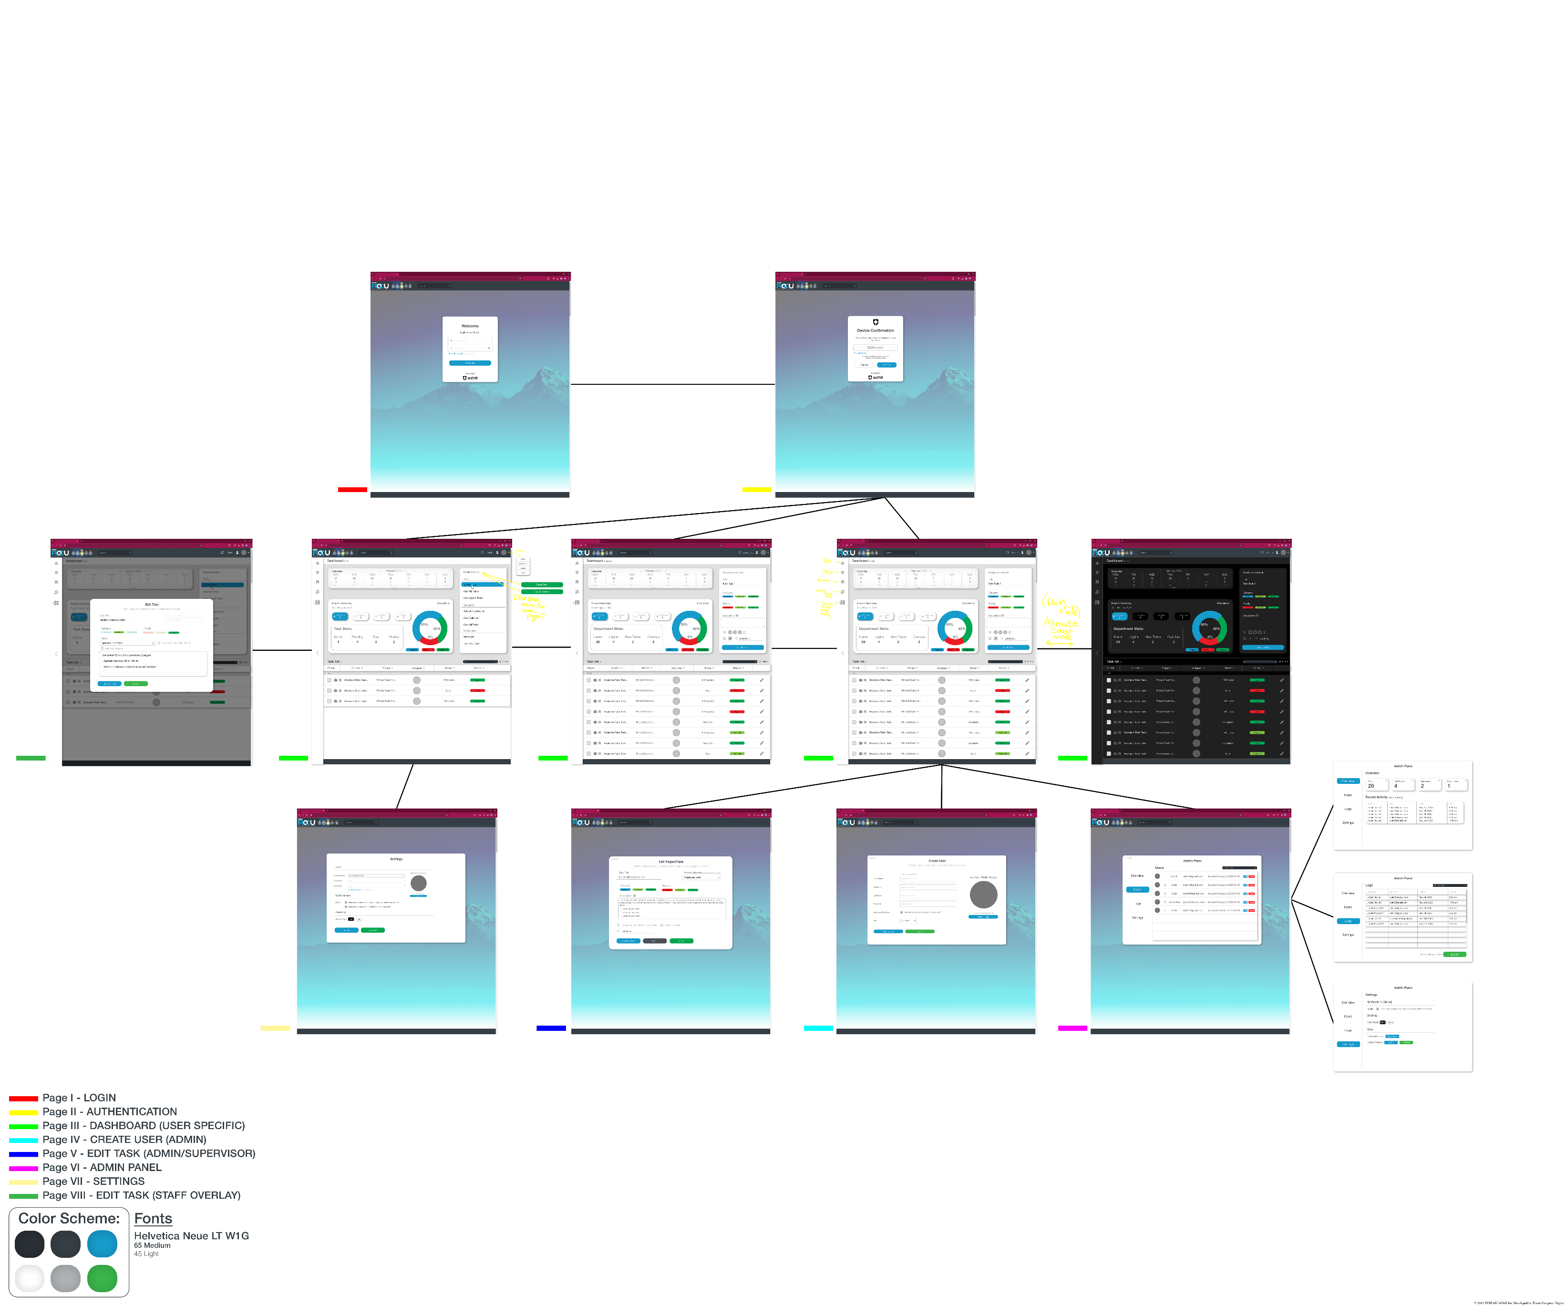

This is a general layout diagram of how the website starts from PAGE I – LOGIN and how it is navigated.

**4.2 Login & Authentication**

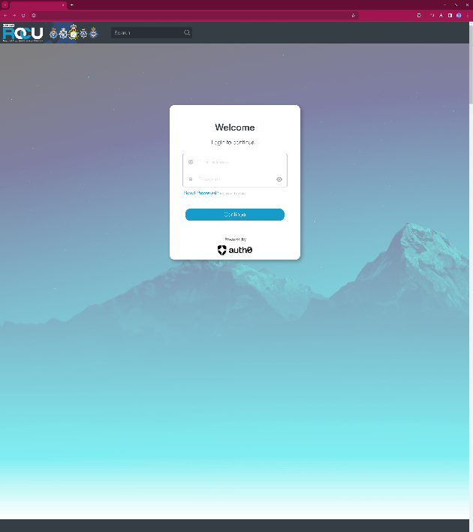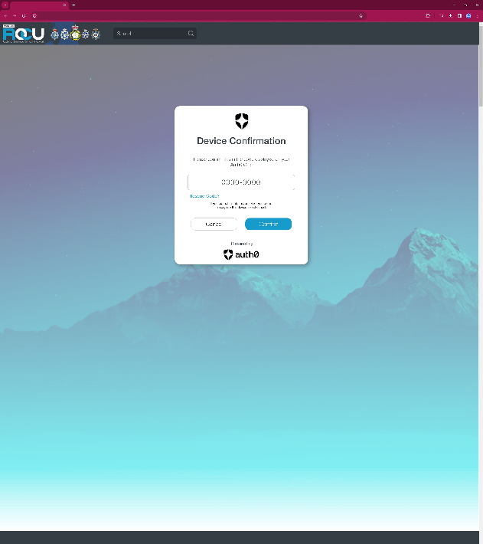

Starting at Page 1, you are asked to log in.

Provide the users email address and password. Login triggers database connection if the details exist.

Password reset will send an email/notification and is done through admin user access level for security.

Page 2, using Open Authentication, will send a code to your device for login security.

**4.3 Dashboard**

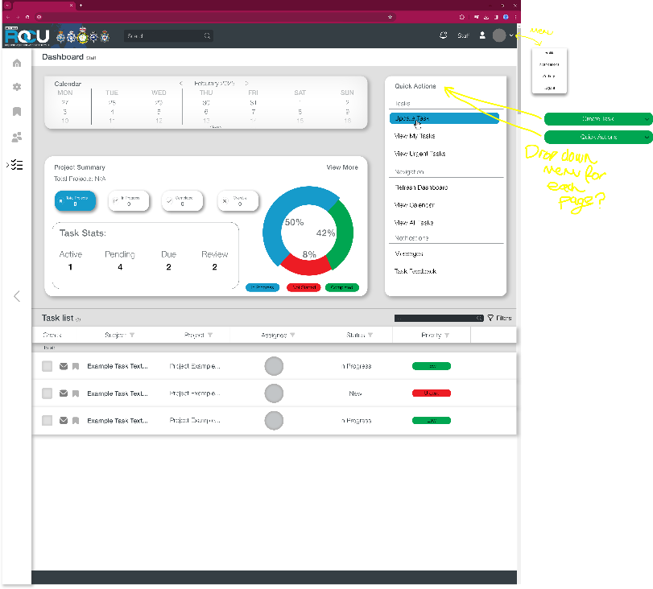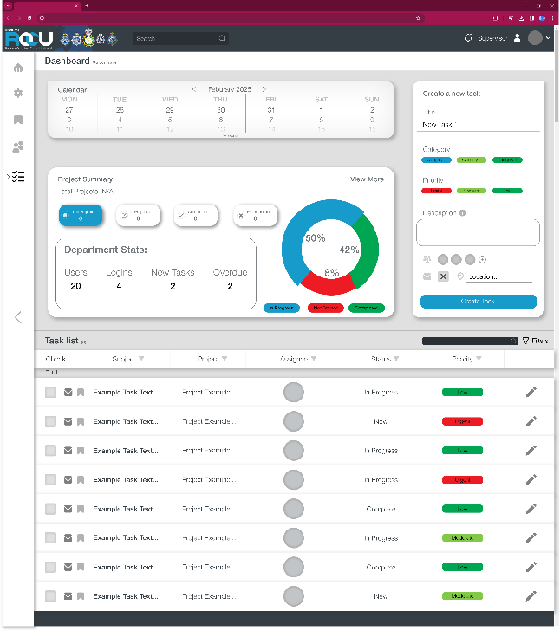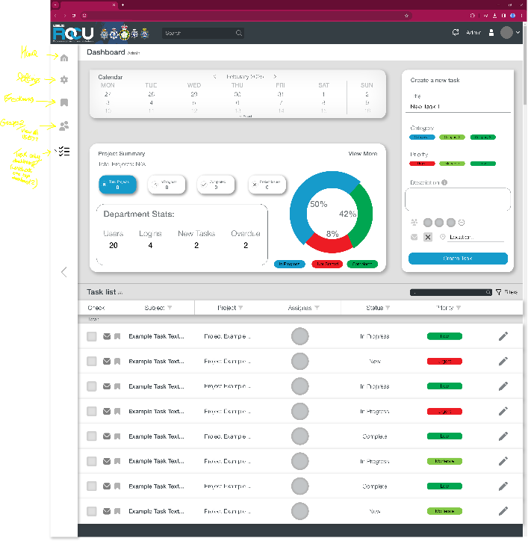

After user authentication, depending on the access level of that user’s account, the site will redirect to Page 3 which is the dashboard.

Here the user can see stats based on the access level (for admins & supervisors all task and project data are shown, for staff their task and project data are shown).

Create task column is only shown to admins & supervisors, task details, assigned users and tags can be an added here.

Task list will show all tasks relevant to that users access level (all tasks are shown for admin & supervisors, only their tasks are shown to staff).

**4.4 Dark Mode**

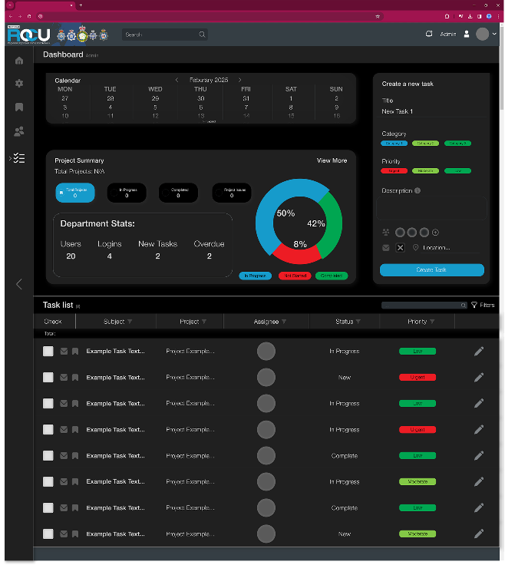

Alternate lighting styles, Light & Dark Mode, will be available to switch from.

Here is an example of the dashboard with Dark Mode enabled.

**4.5 Admin Panel**

**The admin panel can be accessed through Admin user access level.**

**This panel allows admins to see an overview of all users, projects, tasks.**

**Users tab will allow admins to see a list of all users in the database and edit, delete them.**

**Logs tab will allow admins to see a list of logs for every task or project, time, date and who the actor is. Exporting all logs from the database will create a CSV file for the user to download.**

**Settings, like normal user settings, will also allow global notification settings to be written, download data or backup and restore.**

**4.6 Settings & Create User**

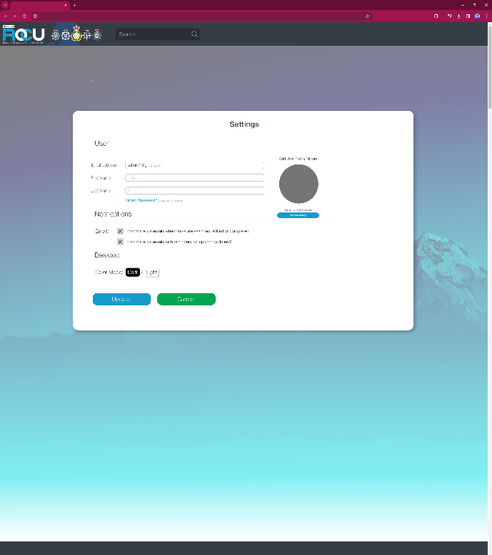

**Settings can be accessed via the drop-down menu on the right of the top bar. (4.3 Dashboard)**

**Users email address and profile picture can be changed while First & Last name cannot and is restricted to Admin user access level.**

**Notifications to inform the user via email can be opted in or out of here.**

**Colour modes can be changed here also, setting stored in the database per user.**

**4.7 Edit Task**

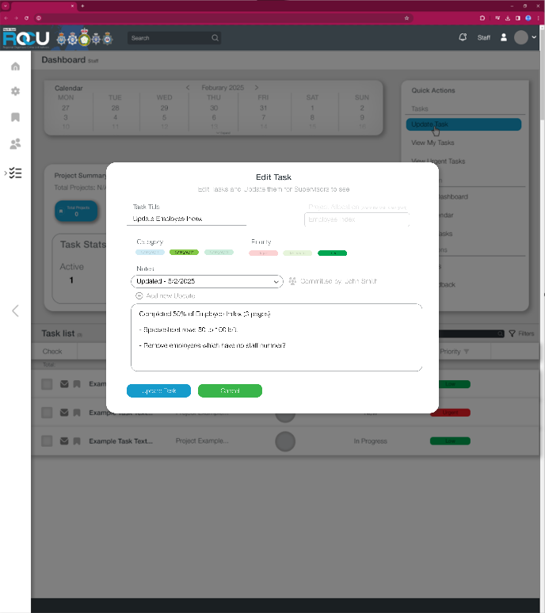

**For admins & supervisors, editing tasks will allow for every detail to be changed: title, project allocation, category, priority, description, assigned users, location.**

**Project allocation can be changed via drop down menu showing all current projects available.**

**Tasks & Projects cannot be deleted, only archived.**

**For staff, editing tasks will allow for certain details to be changed: Add notes/updates (shows actor who committed and date of commit) Can be navigated via drop down menu for each task. This will be a permanent change log for each task.**